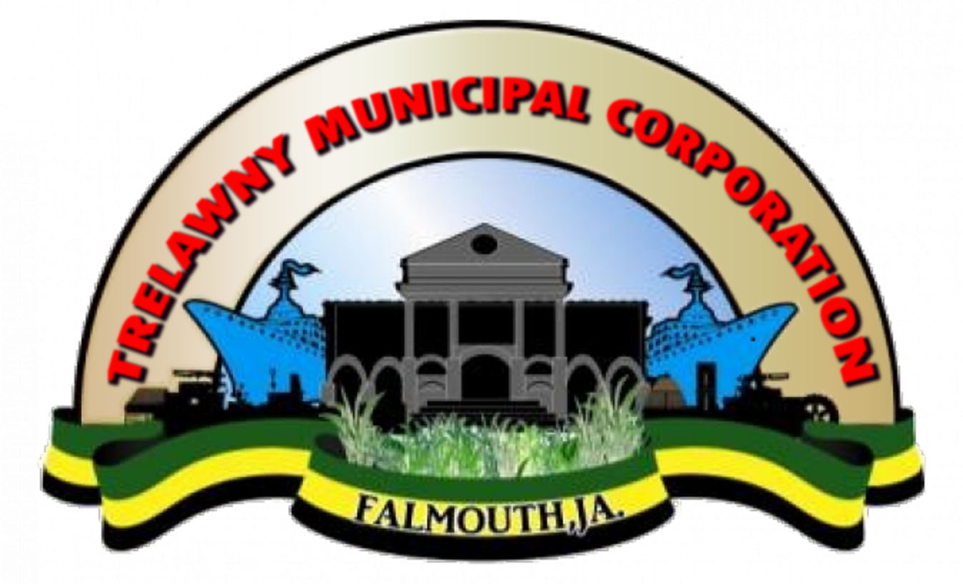
DEVELOPMENT ORDERS

The Town & Country Planning Act of 1957 empowers the Town & Country Planning Authority to prepare, in consultation with the Local Planning Authority, legal documents called Development Orders for specific areas throughout Jamaica.
Contact your Local Planning Authority for more information.

The aim of these documents is to regulate and control the use of land ensuring that land is not misused but is complementary rather than conflicting.
Development Orders were first prepared for sensitive areas extending along the coast of the Parishes.
The Development Order for Trelawny covers the entire parish and was confirmed as a legal document in 1980.
FUNCTIONS OF DEVELOPMENT ORDERS
- Specify the specific areas to which they relate.
- Give directions as to how one may obtain planning permission for development within the areas to which the orders apply.
- Include a development plan, showing a proposed land use strategy for special areas such as parish capitals or conservation areas.
- Restrict developments to those areas where major services either exist or are to be planned.

Trelawny Municipal Corporation
Water Square
Falmouth
Trelawny
Tel: (876) 954-3228
(876) 617-4572

_________________________

TRELAWNY
MUNICIPAL CORPORATION
A Guide to Development

Keeping
you
Informed!

SOME FACTS ABOUT THE DEVELOPMENT OF LANDS
- Development is the carrying out of building, engineering, mining or other operations in, on, over or under the land, the making of any material change of use of any building or land.
- The National Environment & Planning Agency (NEPA) in conjunction with the Municipal Corporation regulates the type of development to be carried out (and the size and form of lots) in the Development Order Areas.
- Before any money is spent acquiring land for development or on preparing plans and drawings, the developer should seek professional guidance in respect of the zoning regulations relating to the specified area where his development is proposed.
- No permission or consent will be given to develop land when the proposed land use will not be to the advantage of the district in which it is located.
- No development will be permitted in any area if such development is contrary to the current development policy of the government or zoning regulations.
- The applicant or his agent should consult with the Local Planning Authorities before starting on any design work.
- The Local Planning Authority for Trelawny is the Trelawny Municipal Corporation.
- Where an area falls between two parishes, the Local Planning Authority is the person or body appointed by the Ministry, such as the Negril Green Island Area Local Planning Authority where, Negril falls within Hanover and Westmoreland.

- Under the Town and Country Planning Act, any material change of use of any buildings or land requires planning permission. For example, if you have a house and want to change it to a commercial building (such as a shop) you need to submit plans to the Municipal Corporation.
- All applications for development permission must be submitted to the Planning Authorities through the offices of the Municipal Corporation.
- No application must be submitted directly to the National Environment & Planning Agency.

If an applicant is aggrieved by the decision handed down by the Local Planning Authority with regard to a development, then s/he can appeal to the Minister within twenty-eight (28) days of receipt of the letter.

