HOW LONG DOES THE PROCESS TAKE?

Approximately six to eight (6-8) weeks, however other departmental and agency recommendations may affect the timeline.
WHAT DO I DO AFTER THE PLAN HAS BEEN APPROVED?

You are required to:
- Pick up your approvals. If you are not the owner, s/he must give you a Letter of Authorization, stamped and signed by a Justice of the Peace or a Notary Public.
- Commence construction within two (2) years of the issuance of the permit. (renewable every six (6) months) then after which this permit will lapse unless an extension of the period had in the meantime being approved by the Municipal Corporation.
- Notify the Chief Engineering Officer in writing of the date on which it is proposed to commence construction. Keep a copy of the approved plan and permit on site for inspections by various agencies.
N.B. For temporary buildings, the permit is to be renewed yearly.
WHAT HAPPENS IF MY APPLICATION HAS BEEN REFUSED?

If your application has been refused, the Corporation is required to do the following:



- Write a notification letter to you stating the reasons for refusal and guide you as to the process that you can take to appeal this decision or to re-apply.

Contact your Local Planning Authority for more information.

Trelawny Municipal Corporation
Water Square
Falmouth
Trelawny
Tel: (876) 954-3228
(876) 617-4572

TRELAWNY

MUNICIPAL

CORPORATION

Building Plan Submission
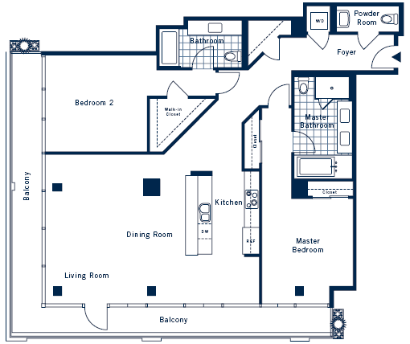
A BUILDING means a domestic building, public building, a building of the warehouse class and any other physical structure, whether a temporary structure or not, any part of the structure, and any architectural or engineering product or work erected or constructed on, over or under land or the sea or other body of water.
A BUILDING PERMIT is a formal approval from your Local Planning Authority (L.P.A.) (Municipal Corporation) to construct, modify, extend, renovate or change the use of any structure.
WHAT DO I NEED TO TAKE TO THE COROPORATION?

- No. Of Plans Needed:
Residential | Four (4) Sets
Commercial | Seven (7) Sets
Institutional | Seven (7) Sets
Hotels, resorts etc | Eight (8) Sets
Industrial | Seven (7) Sets
- Documents Required:
a. Completed Application Form with prescribed fee.
    - Proof of Ownership which can be:
- Copy of Registered Title
- Copy of Sales Agreement with Surveyor’s Diagram
- Copy of Probated Will*
- Copy of Deed of Gift*
  - * Accompanied by a letter from a Lawyer or Justice of the Peace If you are not the owner of the land, a Letter of Authorization from the owner, stamped and signed by a Justice of the Peace or a Notary Public should be presented.
    - Certificate of Property Tax Payment
    - Surveyor’s Diagram/Report
Other documents may be required to conduct a complete review of the application, where necessary.
WHAT DRAWINGS DO I NEED TO TAKE TO THE CORPORATION?

  - Location Map with the site indicated (Scale 1:12,500) with two coordinate points.
  - Site Plan (Scale 1:100)
  - Floor Plan (Scale 1:50)
  - Foundation Plan (Scale 1:50)
  - Drainage Plan (Scale 1:50)
  - Roof Sheet (Scale 1:50)Plan
  - 2 Elevations & Sections (Scale 1:50)
  - Electrical Plan (Scale 1:50)
WHAT ARE THE FEES REQUIRED FOR PROCESSING PLANS?

- Residential - $225.00 per sq.m.
- Multi- Family - $250.00 per sq.m
- Commercial - $350.00 /sq.m.
- Hotels, resorts - $400.00 / sq.m.
- Institutional - $175.00 /sq.m.
- Industrial - $315.00 /sq.m
- Telecommunication - $200,000.00
- Revalidation - $15,000.00
- Restrictive Covenant - $50,000.00
- Fireworks -$50,000.00
- Site Inspection Fees
$8500.00 per inspection; The number of inspections will be determined by the Building Officer upon assessment of the application.
WHAT IF I ERECT A BUILDING WITHOUT AN APPROVED PERMIT?

Anyone who is found to be building without a permit may be issued a Stop Notice requesting IMMEDIATE CESSATION OF WORKS until the plan is submitted, approved and a permit is issued. Failure to comply renders you liable to a fine of $25,000 to $1,000,000 or in default of payment a term of imprisonment not exceeding six (6) months.
Where a Stop notice is served, the Local Planning Authority must serve an Enforcement Notice within fourteen (14) days of the Stop Notice.
Failure to adhere to an Enforcement Notice can result in a fine of $25,000.00 or twelve (12) months maximum in jail. If the use is continued, it is a further offence subject to a fine not exceeding $5000.00 per day on which the use is continued. Default in payment of this fine can result in the land being forfeited to the Crown.

